Soil Permeability and Seepage
- A sand sample of 35 cm² cross sectional area and 20 cm long was tested in a constant head permeameter. Under a head of 60 cm, the discharge was 120 ml in 6 minutes. The dry weight of sand used for the test was 1120 g and G_{s}=2.68. Determine (a) the hydraulic conductivity in cm/sec, (b) the discharge velocity, and (c) the seepage velocity (Ans – 3.174 x 10⁻³ cm/sec, 9.52 x 10⁻³ cm/sec, 2.36 x 10⁻² cm/sec)

- 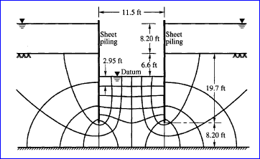 Two lines of sheet piles were driven in a river bed as shown in figure. The depth of water over the river bed is 8.20 ft. The trench level within the sheet piles is 6.6 ft. below the river bed. The water level within the sheet piles is kept at trench level by resorting to pumping. If a quantity of water flowing into the trench from outside is 3.23 ft³/hour per foot length of sheet pile, what is the hydraulic conductivity of the sand? What is the hydraulic gradient immediately below the trench bed? (Ans – 1 x 10⁻⁴ ft/sec, 0.50)

- 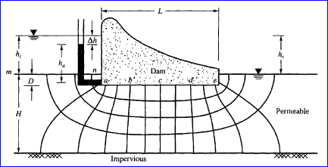A concrete dam is constructed across a river over a permeable stratum of soil of limited thickness. The water heads are upstream side 16 m and 2m on the downstream side. The flow net constructed under the dam gives N_{f} = 4 and N_{d} = 12. Calculate the seepage loss through the subsoil if the average value of the hydraulic conductivity is 6 x 10⁻³ cm/sec horizontally and 3 x 10⁻⁴ cm/sec vertically. Calculate the exit gradient if the average length of the last field is 0.9 m. Assuming e=0.56 and G_{s} = 2.65, determine the critical gradient. Comment on the stability of the river bed on the downstream side. (Ans- 0.626 cm³/sec, 1.30, 1.06. Since the exit gradient is greater than the critical gradient, the river bed on the downstream side will be subjected to quick condition.)
Effective Stress and Pore Water Pressure
- The depth of water in a well is 3 m. Below the bottom of the well lays a layer of sand 5 meters thick overlying a clay deposit. The specific gravity of the solids of sand and clay are respectively 2.64 and 2.70. Their water contents are respectively 25 and 20 percent. Compute the total, Intergranular and pore water pressures at pints A and B as shown in figure. 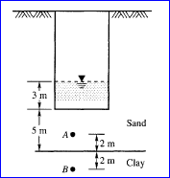 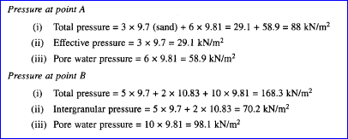

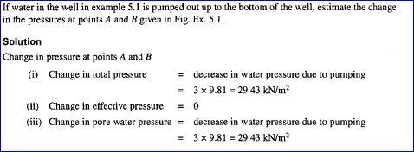
- A trench is excavated in fine sand for a building formation, up to a depth of 13 ft. The excavation was carried out by providing the necessary side supports for pumping water. The water levels at the sides and the bottom of the trench are as given in figure. Examine whether the bottom of the trench is subjected to a quick condition if G_{s}=2.64 and e=0.7. If so, what is the remedy? 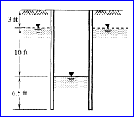 (Ans- There will be quick condition. Critical hydraulic gradient = 1.54)
- 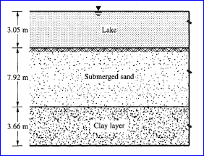 A clay layer 3.66 m thick rests beneath a deposit of submerged sand 7.92m thick. The top of the sand is located 3.05 m below the surface of a lake. The saturated unit weight of the sand is 19.62 kN/m³ and of the clay is 18.36 kN/m³. Compute: (a) the total vertical pressure, (b) the pore water pressure and (c) the effective vertical pressure at mid height of the clay layer. (Ans – 218.9 kN/m³, 125.6 kN/m³, 93.3 kN/m³)
- 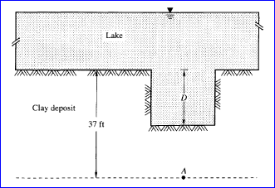 The surface of a saturated clay deposit is located permanently below a body of water as shown in figure. Laboratory tests have indicated that the average natural water content of the clay is 47% and that the specific gravity of the solid matter is 2.74. What is the vertical effective pressure at a depth of 37 ft below the top of the clay? If the water level remains unchanged and an excavation is made by dredging, what depth of clay must be removed to reduce the effective pressure at point A at a depth of 37 ft by 1000 lb. /ft²? (Ans- 1754 lb./ft², 21.1 ft)
- 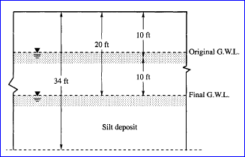 The water table is lowered from a depth of 10 ft to a depth of 20 ft in a deposit of silt. All the silt is saturated even after the water table is lowered. Its water content is 26 %. Estimate the increase in the effective pressure at a depth of 34 ft on account of lowering the water table. Assume G_{s}=2.7. (Ans- 624 lb./ft²)

