Soil Phase Relationships and Index Properties
- A sample of wet silty clay soil has a mass of 126 kg. The following data were obtained from laboratory tests on the sample: Wet density = 2.1 g per cm³, G = 2.7, water content w = 15%. Determine: (i) dry density, (ii) porosity, (iii) void ratio and (iv) degree of saturation (Ans: 1826.2 kg per meter cube, 32.37%, 0.4786, 84.6%)
- Earth is required to be excavated from borrow pits for building an embankment. The wet unit weight of undisturbed soil is 18 kN/m³ and its water content is 8%. In order to build a 4 m high embankment with top width 2 m and side slopes 1:1, estimate the quantity of earth required to be excavated per meter length of embankment. The dry unit weight required in the embankment is 15 kN/m³ with a moisture content of 10%. Assume the specific gravity of solids as 2.67. Also determine the void ratios and the degree of saturation of the soil in both the undisturbed and remolded states. (Ans: 21.55 meter cube, 0.56, 36.9%, 0.75, 35.6%)
- The moisture content of an undisturbed sample of clay belonging to a volcanic region is 265% under 100% saturation. The specific gravity of the solids is 2.5. The dry unit weight is 21 Ib/ft³. Determine (i) the saturated unit weight, (ii) the submerged unit weight, and (iii) void ratio. (76.65 Ib/ft³ , 14.25 Ib/ft³ , 6.59)
- A sedimentation analysis by the hydrometer method (152 H) was conducted with 50 g of oven dried soil. The volume of soil suspension is V = 10³ cm³. The hydrometer reading was 19.50 after a lapse of 60 minutes after the commencement of the test. Given: C_{m} (meniscus) = 0.52, L (effective) = 14 cm, C₀ (zero correction) = +2.50, G_{s} = 2.70 and μ = 0.01 poise. Calculate the smallest size particle, which would have settled a depth of 14 cm and the percentage finer than this size. Temperature of test = 25°C. (Ans: 0.0064 mm, 36.23%)
- A 500 g sample of dry soil was used for a combined sieve and hydrometer analysis (152 H type hydrometer). The soil mass passing through the 75 μ sieve = 120 g. Hydrometer analysis was carried out on a mass of 40 g that passed through the 75 μ sieve. The average temperature recorded during the test was 30°C. Given: G_{s} = 2.55, C_{m} (meniscus) = 0.50, C_{o} = +2.5, μ = 8.15 x 10^{~3} poises. The actual hydrometer reading R_{a} = 15.00 after a lapse of 120 min after the start of the test. Determine the particle size D and percent finer P'% and P%. (Ans: 0.0043 mm, 41.57 %, 10%)
- An undisturbed sample of soil has a volume of 100 cm cube and mass of 190 g. On oven drying for 24 hours, the mass is reduced to 160 g. If the specific gravity of grains is 2.68, determine the water content, voids ratio and degree of saturation of the soil. (Ans: 18.8%, 0.67, 74.4%)

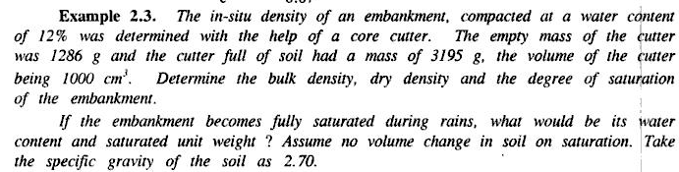
(Ans: 1909 g per cm cube, 16.72 kN per meter cube, 55.5%, 21.6%, 20.34 kN per meter cube)
- The in-situ percentage void of a sand deposit is 34 percent. For determining the density index dried sand from the stratum was first filled loosely in a 1000 cm cube mould and was then vibrated to give a maximum density. The loose dry mass in the mould was 1610 g and dense dry mass at maximum compaction was found to be 1980 g. Determine the density index if the specific gravity of the sand particles is 2.67. (Ans: 46.5%)
- A natural soil deposit has a bulk unit weight of 18.44 kN/m³ and water content of 5 percent. Calculate the amount of water required to be added to 1 cubic meter of soil to raise the water content to 15 percent. Assume the voids ratio to remain constant. What will then be the degree of saturation? Assume G = 2.67. (Ans: 179 litres, 81.7%)
- It is required to prepare a compacted cylindrical specimen of 40 mm diameter and 80 mm length from oven dry soil. The specimen is required to have water content of 10% and percent air voids of 18%. Taking G = 2.70, determine the mass of soil and mass of water, required for the preparation of the above specimen. (Ans: 155.4 kg, 24.9 kg)

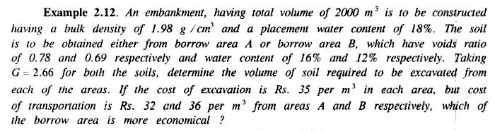
(Ans: Borrow area A is more economical)
- Sandy soil in a borrow pit has unit weight of solids as 26.3 kN per meter cube, water content equal to 11 % and bulk unit weight equal to 16.4 kN per meter cube. How many cubic meter of compacted fill could be constructed of 3500 meter cube of sand excavated from the borrow pit, if the required value of porosity in the compacted fill is 30%. Also compute the change in degree of saturation. (Ans: 2810 meter cube, (0,687 – 0.378))
Shear Strength of Soil
- What is the shearing strength of soil along a horizontal plane at a depth of 4 m in a deposit of sand having the following properties?
Angle of internal friction, ϕ = 35°; Dry unit weight, γ_{d} = 17 kN/m³; Specific Gravity, G_{s} = 2.7
Assume the ground water table is at a depth of 2.5 m from the ground surface. Also find the change in shear strength when the water table rises to the ground. (41 kN/m², 11 kN/m²)
- A direct shear test, when conducted on a remolded shape of sand, gave the following observations at the time of failure: Normal Load = 288 N; shear load = 173 N. The cross-sectional area of the sample = 36cm². Determine: (i) the angle of internal friction, (ii) the magnitude and direction of the principal stresses in the zone of failure.
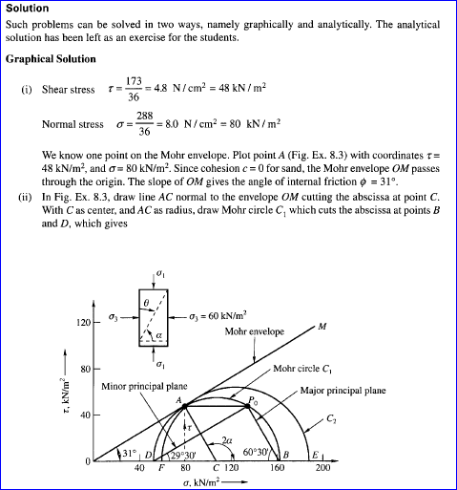
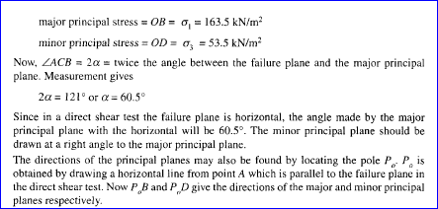
- A saturated specimen of cohesionless sand was tested under drained conditions in a triaxial compression test apparatus and the sample failed at a deviator stress of 482 kN/m² and the plane of failure made an angle of 60° with the horizontal. Find the magnitudes of the principal stresses. What would be the magnitudes of the deviator stress and the major principal stress at failure for another identical specimen of sand if it is tested under a cell pressure of 200 kN/m²? (Ans- 723 kN/m², 241 kN/m², 600 kN/m², 400 kN/m²)

- A cylindrical sample of saturated clay 4 cm in diameter and 8 cm high was tested in an unconfined compression apparatus. Find the unconfined compression strength, if the specimen failed at an axial load of 360 N, when the axial deformation was 8 mm. Find the shear strength parameters if the angle made by the failure plane with the horizontal plane was recorded as 50°. (258 kN/m², 106 kN/m², 10°)

- A soil has an unconfined compressive strength of 120 kN/m². In a triaxial compression test, a specimen of the same soil when subjected to a chamber pressure of 40 kN/m² failed at an additional stress of 160 kN/m². Determine: (i) the shear strength parameters of the soil, (ii) the angle made by the failure plane with the axial stress in the triaxial test. (c = 43 kN/m², ϕ = 19°, 54.5°)

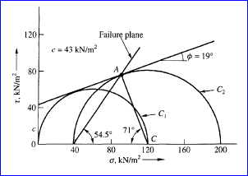

Soil Permeability
- A pumping test was carried out for determining the hydraulic conductivity of soil in place. A well of diameter 40 cm was drilled down to an impermeable stratum. The depth of water above the bearing stratum was 8 m. The yield from the well was 4 m³/min at a steady drawdown of 4.5 m. Determine the hydraulic conductivity of the soil in m/day if the observed radius of influence was 150 m. (234.4 m/day)

- 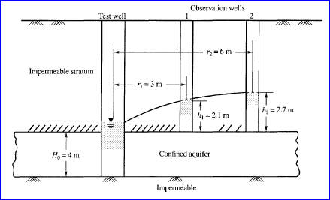 A field pumping test was conducted from an aquifer of sandy soil of 4 m thickness confined between two impervious strata. When equilibrium was established, 90 litres of water was pumped out per hour. The water elevation in an observation well 3.0 m away from the test well was 2.1 m and another 6.0 m away was 2.7 m from the roof level of the impervious stratum of the aquifer. Find the value of k of the soil in m/sec. (1.148 x 10⁻⁶ m/sec)

- The following details refer to a test to determine the value of k of a soil sample: sample thickness = 2.5 cm, diameter of soil sample = 7.5 cm, diameter of stand pipe = 10 mm, initial head of water in the stand pipe = 100 cm, water level in the stand pipe after 3 h 20 min = 80 cm. Determine the value of k if e =0.75. What is the value of k of the same soil at a void ratio e = 0.90? (Ans – 0.826 x 10⁻⁶ cm/sec, 1.3146 x 10 ⁻⁶ cm/sec )

- In a falling head permeameter, the sample used is 20 cm long having a cross-sectional area of 24 cm². Calculate the time required for a drop of head from 25 to 12 cm if the cross-sectional area of the stand pipe is 2 cm². The sample of soil is made of three layers. The thickness of the first layer from the top is 8 cm and has a value of k₁= 2 x 10⁻⁴ cm/sec, the second layer of thickness 8 cm has k₂ = 5 x 10^{~4} cm/sec and the bottom layer of thickness 4 cm has k₃ = 7 x 10^{~4} cm/sec. Assume that the flow is taking place perpendicular to the layers.
